Contributor: June Black

**Korda, Alberto**

Born: 14 September 1928—Havana, Cuba; Died: 25 May 2001—Paris, France

Alberto Fernando Díaz Gutiérrez was born in Cerro, Havana on 14 September 1928. Although he spent long periods of his childhood in the fishing village of Santa Fé, he eventually returned to the capital, where he worked as a salesman until beginning his career in photography. In 1954, he opened an atelier in Old Havana named *Studios Korda* in homage to two Hungarian directors—**Alexander and Zoltán Korda**—whose films had deeply impacted his aesthetic sensibility. By 1956, he had relocated the studio to the heart of fashionable downtown Havana and assumed the name Alberto Korda. The studio was not only a successful business endeavor, but a cosmopolitan site of creativity and innovation, and Korda quickly established himself as a member of the city’s elite. *Studios Korda* revolutionized the attitude toward fashion and photography in Cuba and has been described by scholars as the epitome of Havana’s downtown culture in the 1950s and ‘60s.

On 8 January 1959, Korda’s life, along with those of his fellow islanders, changed dramatically when a caravan of triumphant rebels led by **Fidel Castro** entered Havana. Although Korda was never named Castro’s official photographer, he spent much of his time traveling with the leader and became one of the most recognized photographers of the Cuban Revolution.

Korda’s new political engagement provoked a significant shift in the type of photography he produced. For the first time, he was confronted with the disquieting dichotomy of the constructed reality he captured in his studio and the experience of the Cuban masses. Relatively few of Korda’s film rolls contain images of the Argentinian revolutionary **Ernesto “Che” Guevara**; however, on 5 March 1960, Korda, like other photo journalists, attended a memorial service for victims of the explosion of *La Coubre* in the Port of Havana. He took many photos of Castro, but only two of Che. While images of Castro appeared the next day in the papers, the now famous *Guerillero heroico* hung in Korda’s studio for nearly a decade without being published. Before Che’s death in 1967, Korda’s image had already begun to appear as far away from Cuba as France and Vietnam; however, it was after the revolutionary’s assassination in Bolivia, that the image garnered global attention.*Guerillero heroico* has since become a universally recognized symbol of revolution. However, it has also been extensively appropriated for product sales unrelated to Korda’s political aims.

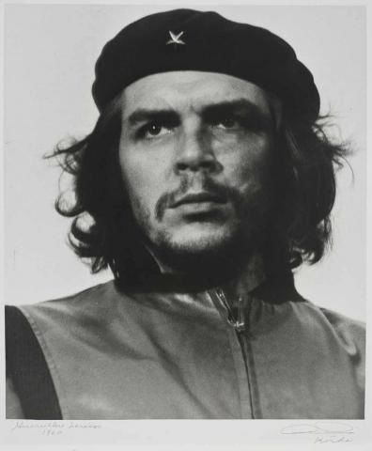

Alberto Korda

*Guerillero heróico (Heroic Guerilla)*, 1960

Gelatin silver print

ARTstor

In 1968, Korda’s studio was raided and his association with Castro ended. Although Korda continued to photograph and participate in photography exhibitions until his death in 2001, he is best remembered for his iconic image of Che.

**References and Further Reading:**

Casey, M. (2009) *Che’s Afterlife: The Legacy of an Image*, New York: Vintage Books.

Loviny, C. ed. (2006) *Cuba by Korda*, Melbourne, Australia: Ocean Press.

Sanders, M. and Vives, C. eds. (2008) *Korda: A Revolutionary Lens*, Göttingen, Germany.: Steidl Verlag.

Lopez, L. and Ziff, T. directors, (2008) *Chevolution: The Man, the Myth, the Merchandise: The Story of the World’s Most Reproduced Photograph*, DVD, Los Gatos, California: Red Envelope Entertainment.

**List of Works:**

*Fidel Visits an Oil Well in Jatibonico, Las Villas*

1960

gelatin silver print

*Abraham Lincoln Memorial, Washington, 19 April 1959*

1959

gelatin silver print

*Parade in Revolution Square, Havana, 1 May 1962*

1962

gelatin silver print

*Portrait of Pablo Neruda, January 1961*

1961

gelatin silver print

*La niña de la muñeca de palo (Girl with a wooden doll), Sumidero, Pinar del Rio, February 1959*

1959

gelatin silver print

*El quijote de la farola (The Quixote of the lamp post)*

1959

gelatin silver print

*Self-Portrait*

c. 1954

gelatin silver print

*Norka*

c. 1956-58

gelatin silver print

*Julia, Brisas del Mar, Havana*

c. 1956

silver gelatin print

*Parade in Revolution Square, Havana, 2 January 1961*

1961

silver gelatin print